Lab report 2: 2024/03/23

* In the first task I learned to convert an image to grayscale using cvtColor() function and save it.

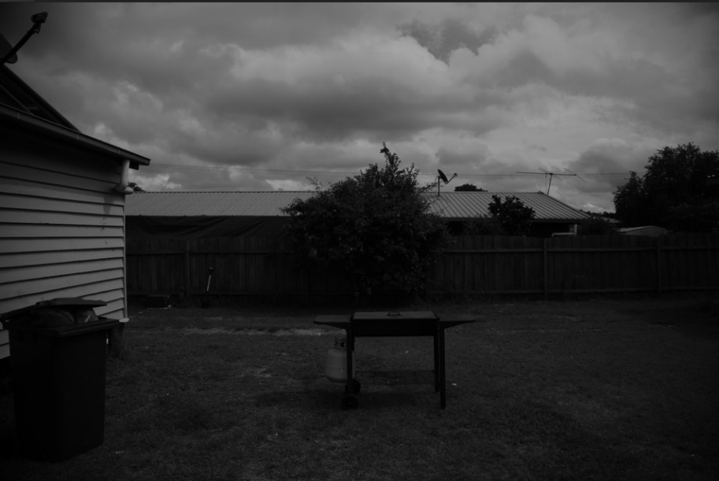

* In the second task I learned to implement min filter and max filter on a grayscale image. Also, I put the functions in a separate file in then included it in the main file. tried many kernel sizes and
  + The best to remove the electric cables from garden image was size 5.
  + The best to remove the noise from astronaut was 3 min
  + The best to remove the noise from lena was 3 min

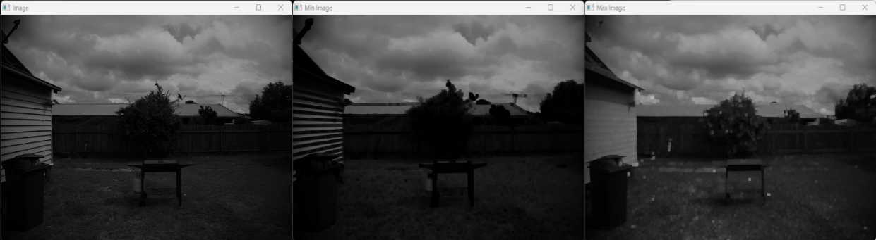

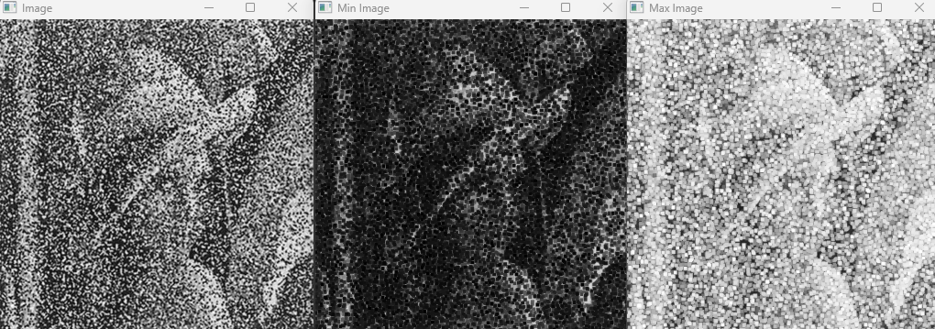

* In the third and forth task I expanded the second task and added Gaussian smoothing and Median filter. Still the best kernel size = 5.

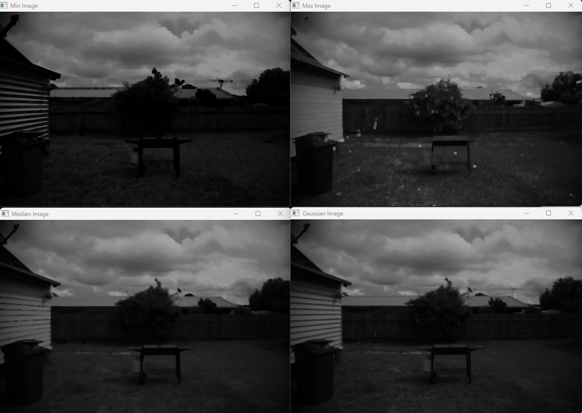

* 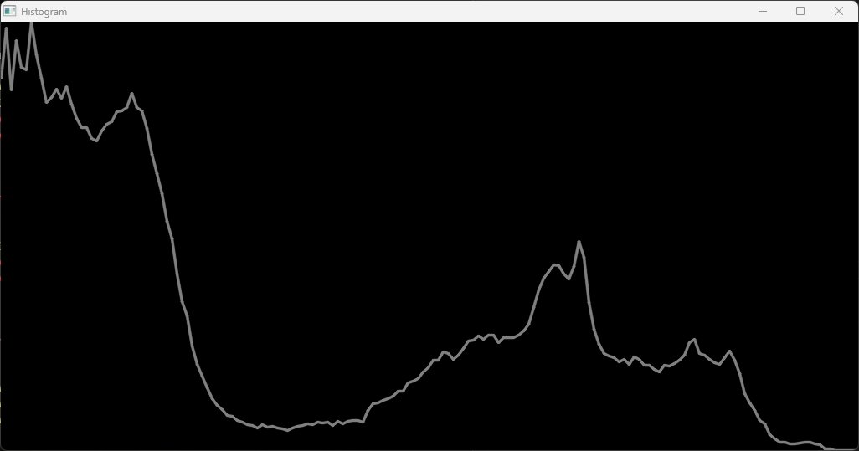In the fifth task I learned how to plot the histogram of an image. The best range for histogram of the given image was about [0,180].
* In the sixth task I learned how to get the histogram equalization of an image using OpenCV function. Done both on gray and color image.

